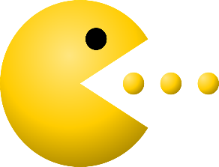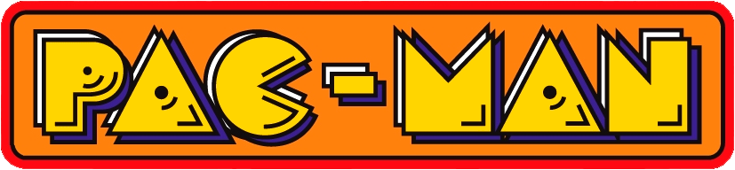

**Core Concept**: Object Oriented Programing

Object Oriented Programing is a type of programing used to make games. In Object Oriented Programing, each **THING** and **OBJECT** has its own code.

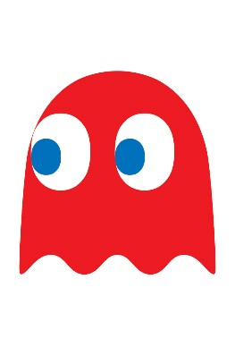

Object Oriented Programing means that different objects can follow different instructions.

Here is a list of the Different Objects in the PacMan Game:

* 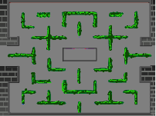The Background



* PacMan



* Each Ghost



* Each Pellet

You can see the code for each Object by clicking on the sprite image.

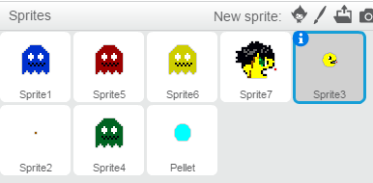

This is the PacMan Sprite.



You Can Click on the to Change the name of the Sprite:



Change the name of the PacMan Sprite here.

If you followed the User Interface Core Concept, Paceman’s Scripts should look like this:

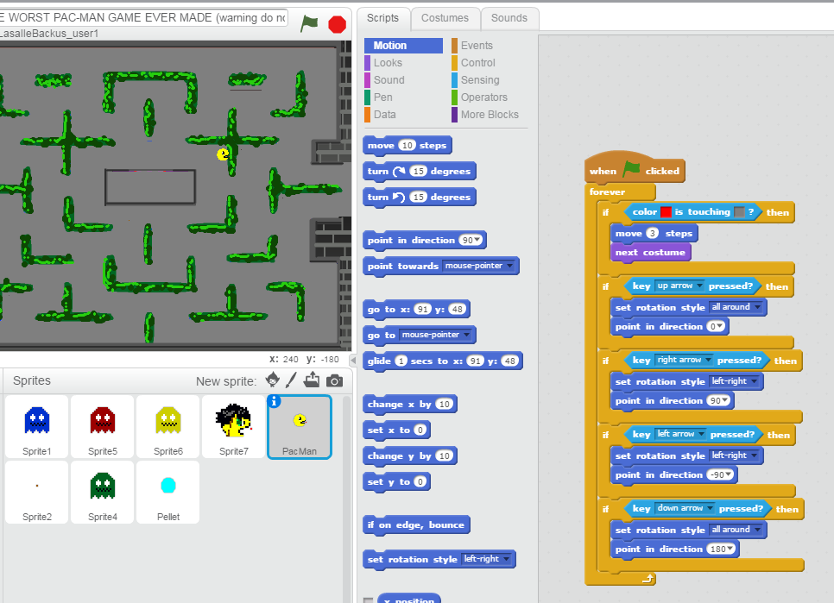

If you click on a Ghost, He should have No Code. This means the Ghost has no instructions to follow.

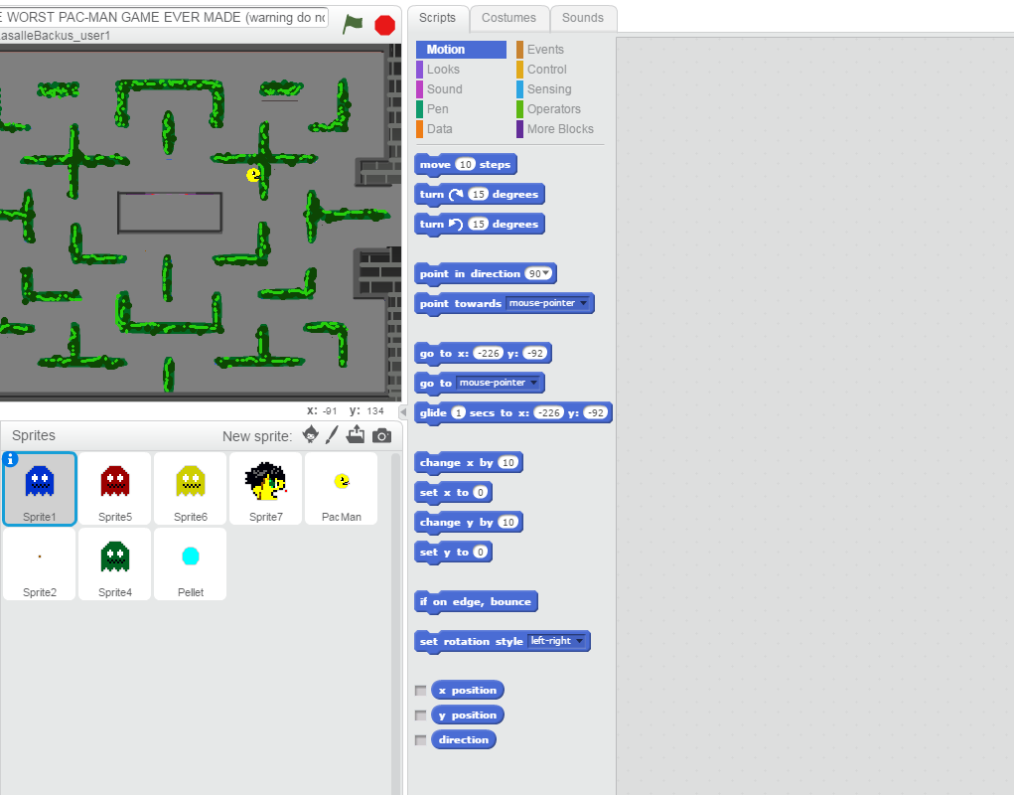

To make the Ghost Move I need to give him some Code in his script window.

Here is some example Code to Add to the Ghost’s Script Window:

**Code STORY**

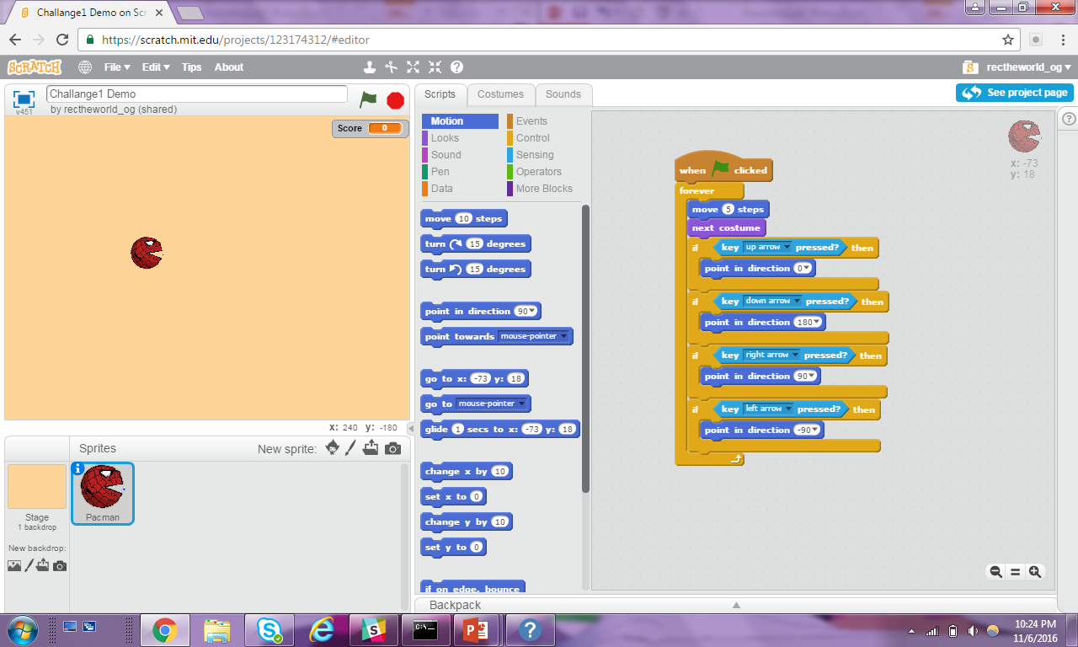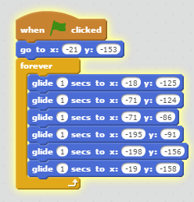

When **START** is Pressed

**MOVE** the Ghost at Starting Position **1**

**WHILE** the Game is Playing

**GLIDE** the Ghost to the Position **2**

**GLIDE** the Ghost to the Position **3**

**GLIDE** the Ghost to the Position 4

**GLIDE** the Ghost to the Position **5**

**GLIDE** the Ghost to the Position **6**

**GLIDE** the Ghost to the Position **1**

This code will have the Ghost Follow a Loop around the Board like this:

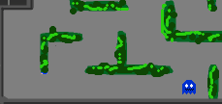

**Position 1**

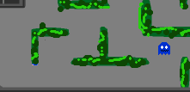

**Position 2**

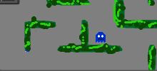

**Position 3**

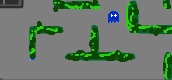

**Position 4**



**Position 5**



**Position 6**



**Position 1**